Solution

Step 1: Open the **Prodiscover basic** tool. The following snapshot shows its user interface.

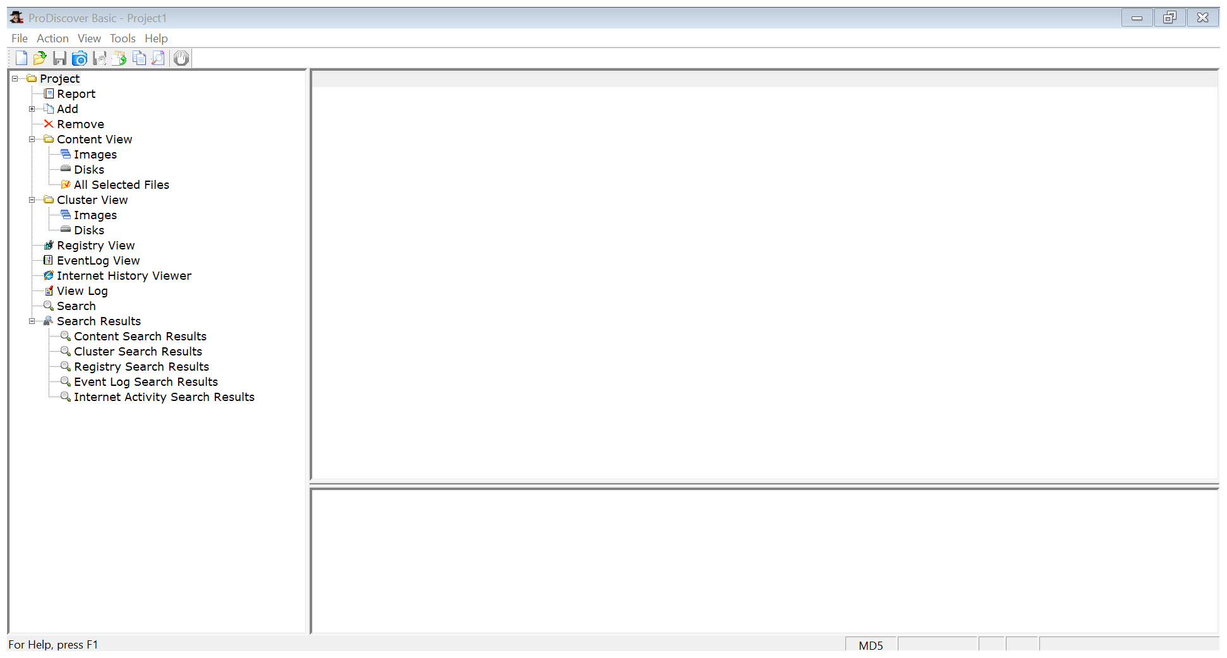

Step 2: Enter the Project number and name and add some description about it. And then click on **Open**.

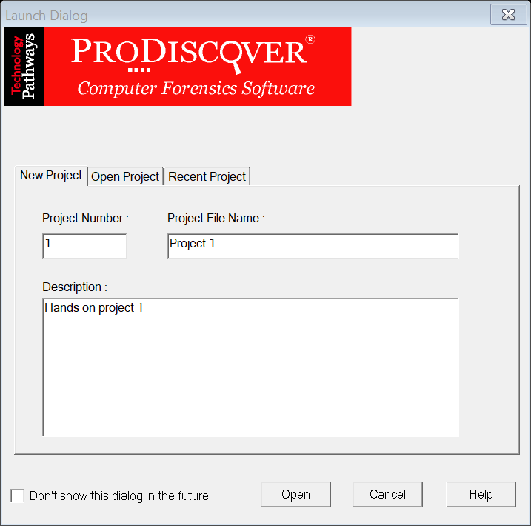

Do not forget to save the project. Go to **File > Save File**. Save the project in any of the folder of our choice.

Step 3: Add the image file **C1Prj02.eve.** Go to **Action>Add>Image File>Navigate to folder** where the image file is saved in our system.

Image file is added successfully.

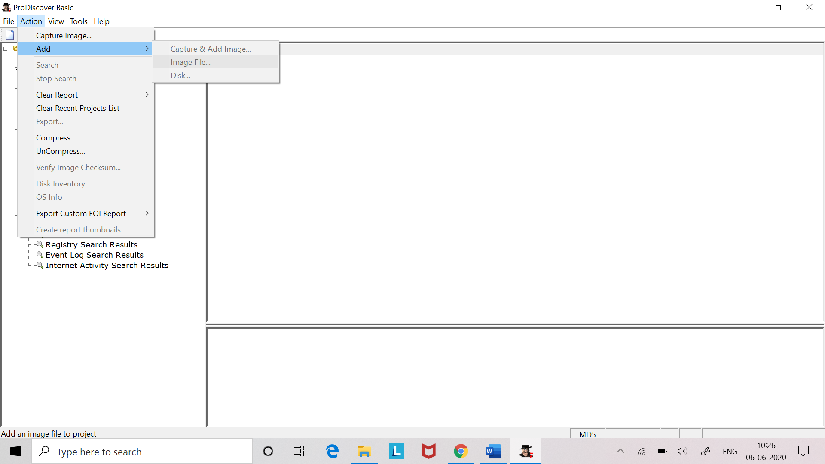

Step 4: Analyze the image file. Go to the **Content view>Images>click** **the pathname** and examine the files listed.

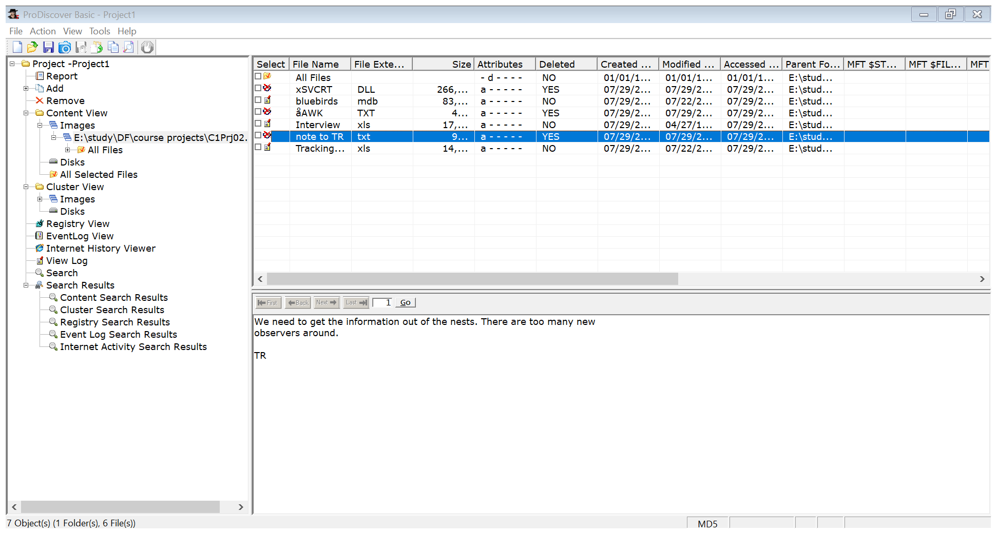

Step 5: Searching(Content search) for the particular keyword.

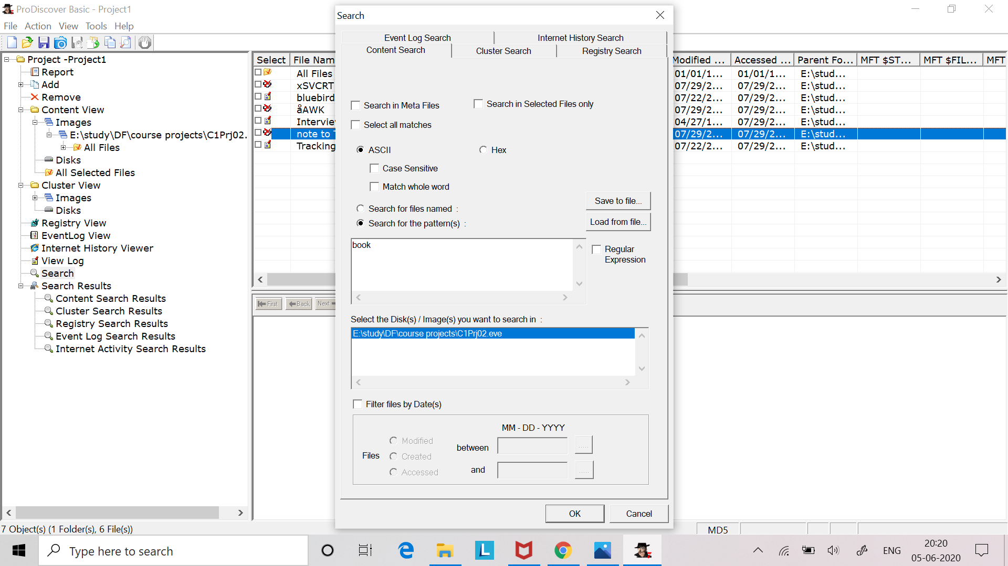

Results will be displayed in **Content search results.**

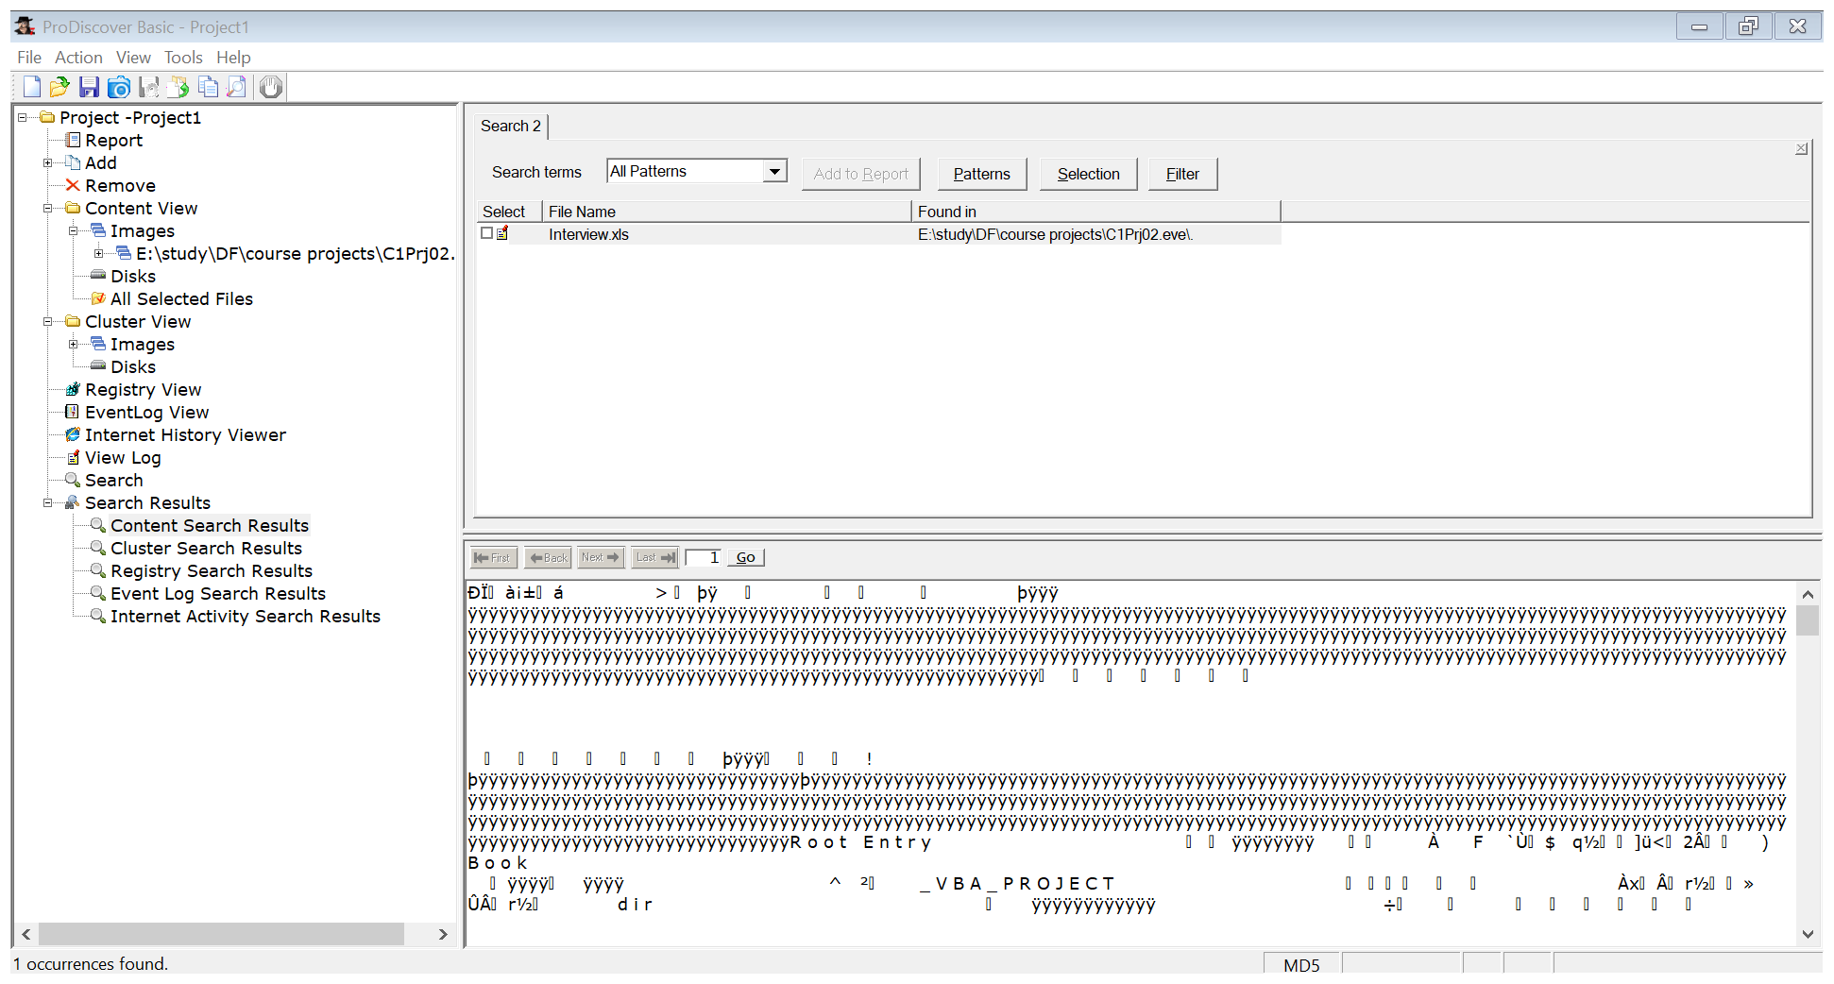

**Interview.xls** file contains the keyword “book”.

Step 6: Searching(Cluster search) for the particular keyword.

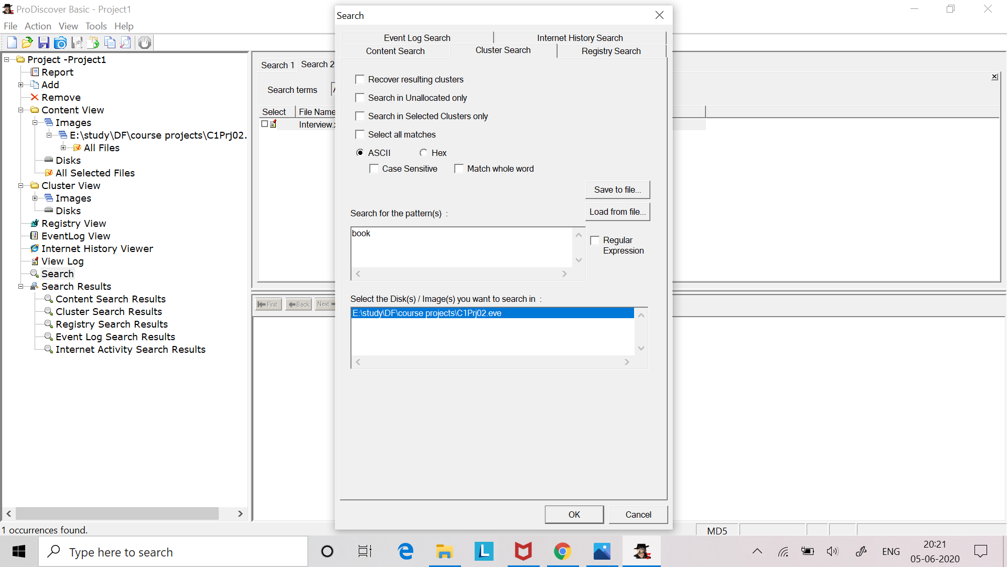

Results will be displayed in **Cluster search results.**

27 clusters are found which contains the keyword “book”.

